2017-9-25

1. To see directories : ls

2. To know the user : whoami

Shows Ec2-user

3. who am I shows along with time how many users logged in

4. To add a user: useradd tester

It says -bash: /usr/sbin/useradd: Permission denied

Denied because, ec2 users doesn’t have an access to create

Root user can do anything on Linux

**5. command : Sudo su - :will take it to root user**

Shows : [root@ip-172-31-81-155 ~]# that this IP address is in root

We can check using whoami

Shows : root

6. now we can add user

Command: useradd tester

7. to give paasword to user tester

Command: passwd tester

It will ask to type new password and retype it.

Shows: passwd: all authentication tokens updated successfully

The same command used to create a new password or to change it to new password

8. short list: ls

to see only directories structure as

[root@ip-172-31-81-155 ~]# ls

anaconda-ks.cfg original-ks.cfg

[root@ip-172-31-81-155 ~]# cd /

[root@ip-172-31-81-155 /]# ls

bin boot data dev etc home lib lib64 media mnt opt proc root run sbin srv sys tmp usr var

[root@ip-172-31-81-155 /]#

9. To see how much size is available in each then use command ll

ll is the longlist.

10. Details:

Bin: if we install any application, the control applications such as starting and end will be in here.

Etc: any configuration files .If we add any user that user’s configuration files will be available in here.

Lib, sbin, usr, sys: Processes and services if available they will be here.

Opt: Like in windows there is C drive, in the same way Opt works in here. Opt, we can use to install the files, all important files can be created here.

tmp: temp contains all the temporary files.

Var: contains all the log files. Any system logs or any application logs that we install are available in here.

mnt: is mount : if we are using other files from stored like emcs, var.

in any organization if we want to share any files (any bulk data) we will create a shared drive between our windows system and who are connected threw lan can access.

Here lan is called as NFS(network file system) .here will create NFS—this will be done by storage admins.

So, we have to mount the files that are sent by Storage admins by mnt

Selinux: all admin related will be taken careof.

11. go to a particular directory

Command : cd opt/

Shows: [root@ip-172-31-81-155 opt]#

12. command: pwd: is present work directory.

Shows: /opt

13. cd ../ command will take 1step back

Pwd shows present directory

To go 2 steps back command : cd ../../

14. create own directory

Like in windows we call it as folder, in linux we call it as directory

Command: mkdir class

Here class is the name of new directory that we gave.

Cd class/

15. To create a file

Command: touch file1

File1 is the name of new file that we want to give

16. to put some information in this file like to edit:

In windows if we clik 2 times file will open, so in linux we use the command:

Vi file1

File1 is the one which we want to edit or to open

To edit we need to be in insert mode

Command for insert

Press escape i

Then shows INSERT

Now we can type hello

To save this text

Command : press escape the :wq!

Write and quit

Press enter then do vi file1

now it is saved.

17. we can put some more file in the same way

18. just to quit

Command :

:q!

19. To see what is there in the file we can use command: vi file1

Or to see this content and don’t want to modify, use command:

Cat file1

It shows as hello

**20. To download any package**

**Google it**

**What you want to download. don’t press on download. Just do right click and copy URL link**

**Command: wget paste that URL link**

Ex:

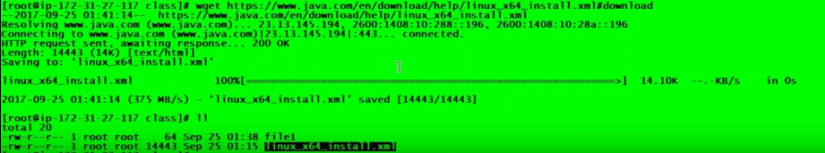

21. 

For ex. If it starts with “d” it is directory

If it starts with empty it is the file

22. like create user, we can create group

Command : groupadd devops

devops is the group name

and can specify the access levels to it by using command

these are done by system admins or by linux admins

for ex: drwxr-xr-x

means 1st one is for user

2nd is for group 3rd for others



To change access command : chmod 766 file1

Means access of file1 to user 7, group 6, others 6

After this to check use command : ll

23. to change owner ship:

chown tester:devops linux_X64_install.xml

tester ----user

devops--- group

now root root are changes to tester devops… ownership is tester ,group is devops.